Logic Gates

Subject:  Related Subjects: | Grade Level(s):  Length of Lesson: | Type: Inquiry / Design / Project  Keywords:

Lesson Overview
Students will learn the concept of logic gates. There are three main types of logic gates—AND gate, OR gate, and NOT gate. To understand how these work, students need to understand how computers “talk”. Computers utilize “binary” to carry out function. Binary is another way of counting numbers. We count 1,2,3,4,5… and so forth. In binary, computers “count” with 0, 1, 11, 100, 101, 110, 111… and so forth. Basically the main idea is that through 0’s and 1’s, the computer is able to do what it does!

Lesson Focus
Students will create circuits using these chips. Possible circuit designs can include a light that turns on if BOTH switches are on, or if EITHER switch is on…etc.

Lesson Objective(s) | Students will learn to use logic gates using breadboards and switch inputs. They will learn the fundamentals of Boolean algebra and how logic gates can work in real world applications

Lesson Timing

5 minutes | Introduce the Lesson
30 minutes | ...

Materials | - Breadboard  - Electronic Logic Gates (7404-inverter, LS32 OR Gate, LS08 AND Gate)  - Switches  - LED lights/Motors
Instructor Prep | - Step 1
Related Resources | - List related lessons/ppts etc available from USC or outside, trusted orgs

Lesson Plan

Introduction
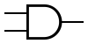
In circuits and logic gates, students can think of 0’s and 1’s as Yes and No’s or + and -. For example, the AND gate is depicted with this symbol on the left: The two prongs on the left are its “inputs” or what it reads. The single prong on the right is its “output”, or what it gives out. In order for an AND gate to put out a “1” it has to read a “1” AND a “1”. Both top AND bottom have to have “1” in order for it to give a “1”. If it reads a “0”, the gate gives out a 0.

The OR gate is different. The symbol looks like this: 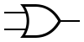
In order for an OR gate to put out a “1”, either the top input OR the bottom input needs to read a “1”. Unlike the AND gate, it puts out a “1” if only one of input reads a “1”. If none of the inputs read a “1” then the OR gate will put out a “0”.

The NOT gate is also different. It looks like this: 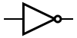
As you can see, it only has one input. What it does is take the input, and gives out the opposite of it. If it sees a “1” it will shoot out a “0”. If it sees a “0” it will shoot out a “1”.

Procedure
Students will attempt to make the following circuits that will light up according to the following scenarios:
Switch A OR Switch B are ON
Switch A AND Switch B are ON
Switch A AND Switch B AND Switch C AND Switch D are ON
Switch A AND Switch B OR Switch Switch C AND Switch D are ON
The pin diagrams for these gates are posted below. These gates need to be connected to power in order to work (Vcc and Gnd)

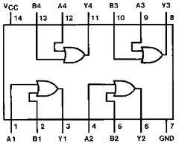

OR GATE ( 74LS32P):

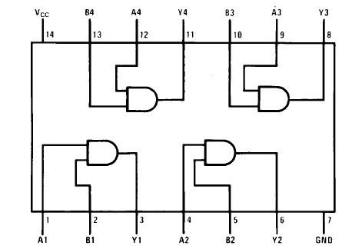

AND GATE ( 74LS08P)

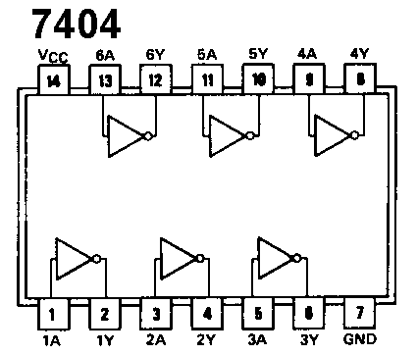

INVERTER (7404N)

Wrap-up
End the lesson with some final discussions about what students designed/discovered. Connect their activity back to the focus question/problem, real world examples, and STEM careers.

Also include notes about any special cleanup considerations

Lesson Background for Teachers

Suggested Real-World STEM Connections
- List possible related Role Models in STEM (with details and links to more reading). Give suggestions for examples of scientists/engineers who are from underrepresented groups in STEM in related careers.
- List related real-world engineering problems and examples

Lesson Variations and Options
Include descriptions of alternative methods or ways to present things.

Explanation
Describe the background concepts and explanations behind the lesson. This can be more in depth than a teacher/instructor would actually share with students.

Key Concepts and Vocabulary
- Word 1: Grade Appropriate Definition
- Word 2: Grade Appropriate Definition

Safety Notes
- Safety instruction

